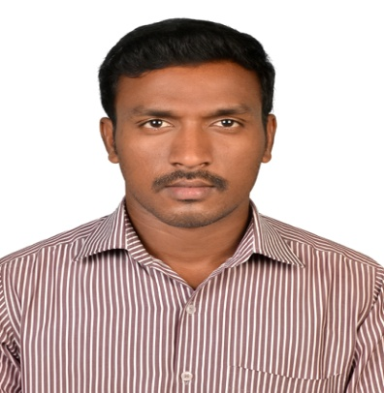

NO.5, KALIYAMMAN KOVIL STREET, THALATHERU, KARAIKAL,

PONDICHERRY

Mobile no: +91-9087302867

Mail id: aspkapilmba@gmail.com

KAPIL DEV.P

Carrier Objectives:

To attain a challenging position in a reputed organization where I can effectively contribute my academic as well as personal talents and provide my best services.

Academic Profile:

|  |  |  |  |  |
| --- | --- | --- | --- | --- |
| Course | Institution | University / Board | Year | Percentage |
| MBA (Finance & Marketing) | Sri Manakula Vinayagar Engineering College | Pondicherry University | 2013-2015 | 68% |
| B.COM,  (Foreign trade) | Indira Gandhi College of Arts & Science | Pondicherry University | 2009-2012 | 55% |
| HSC | V.O.C Government Higher Secondary School | State Board | 2009 | 57% |
| SSLC | Nethaji Subash Chandra Boss Government Higher Secondary School | State Board | 2006 | 56% |

Technical Course:

* Proficiency in Microsoft office.

Area of Interest:

* Financial Management
* Marketing Management
* Customer Relationship Management

Soft Skills:

* Having excellent interpersonal relationships
* Good communication abilities.
* Learn new concept and solve problems in team environment.

Project:

* Done summer project in PG for the project title “A STUDY ON WORKING WOMAN ATTITUDE TOWARDS INVESTMENT IN MUTUAL FUND. Pondicherry, 2014.
* Done summer project in PG (finance specialization). for the project title "A STUDY ON GROWTH AND PERFORMANCE OF SECONDARY MARKET IN INDIA.Chennai,2015

Working Experience:

First, I am worked logistics company **M/S AXPRESS LOGISTICS INDIA PVT LTD**, My designation Sales and Marketing executive from 23-jan-2016 to 28-aug-2017.

Second, I am worked seismic job service company **M/S KARAI OM SAKTHI ENTERPRISES PVT LTD,** My designation operation manager for whole camp from 20-oct-2017 to 15-july-2018 at Madhya Pradesh.

Roles & Responsibilities:

Handle the New and existing customers to increase the sales targets and follow-up collection

Department.

Startup initial work like area scouting and planning the camp establishment, arrange the material, manpower, machinery and focused on billing department. Handling operation team in field.

Personal Details:

Date of Birth : 25-06-1990

Gender : Male

Nationality : Indian

Father’s Name : S.PICHAIYAN

Mother’s Name : P.USHA

Language Known : Tamil, English (wrs) and Hindi (speak)

Hobbies : Playing Cricket, Kabaddi, football,

Place: Karaikal Yours Sincerely

Date: P. KAPIL DEV